TrafficTelligence: Advanced Traffic Volume Estimation with Machine Learning

1. INTRODUCTION

1.1 Project Overview
TrafficTelligence is an intelligent traffic forecasting system powered by machine learning. It predicts real-time traffic volume based on factors like weather, day/time, and historical trends. This project empowers city planners and commuters with data-driven insights to reduce congestion and improve road usage.

1.2 Purpose
The purpose of this project is to develop a system that leverages ML to estimate traffic volume with precision, helping city authorities plan efficiently and allowing travelers to make smarter commuting choices.

2. IDEATION PHASE

2.1 Problem Statement
Increasing urban traffic leads to congestion, time loss, and pollution. A lack of predictive traffic systems limits proactive planning.

2.2 Empathy Map Canvas
- Think & Feel: Wants accurate forecasts
- Hear: Complaints about traffic
- See: Congestion everywhere
- Say & Do: Plans trips inefficiently
- Pain: Wasted time in traffic
- Gain: Real-time data to improve commute

2.3 Brainstorming
Ideas considered:
- Basic traffic dashboard
- Real-time Google Maps alternative
- Forecast model using weather and time
Chosen idea: Prediction system with data visualization and downloadable logs

3. REQUIREMENT ANALYSIS

3.1 Customer Journey Map
User enters inputs → Backend predicts volume → Output displayed → Log stored → User downloads CSV

3.2 Solution Requirement
Functional Requirements: Traffic prediction, UI interface, log storage
Non-Functional Requirements: Usability, performance, scalability

3.3 Data Flow Diagram
See attached diagram (Image included in full submission).

3.4 Technology Stack
- Frontend: HTML, CSS, JS
- Backend: Python (Flask)
- ML: Scikit-learn
- Database: CSV-based log storage

4. PROJECT DESIGN

4.1 Problem Solution Fit
Real-time traffic prediction is essential to solve congestion and route inefficiency problems.

4.2 Proposed Solution
A lightweight ML-based web app that predicts traffic volume and displays trends using UI and logs.

4.3 Solution Architecture
Flow: UI Input → Backend Flask → ML Model → Prediction + Logging → UI Display + File Log
(Architecture image included)

5. PROJECT PLANNING & SCHEDULING

5.1 Project Planning
Sprint 1: Data Collection, Preprocessing, Model Training
Sprint 2: Evaluation, UI design, Visualization, Logs
Sprint 3: Admin tools, Model upload, Final testing

6. FUNCTIONAL AND PERFORMANCE TESTING

6.1 Performance Testing
ML model evaluated using metrics: MAE, RMSE, R2
Prediction latency under 500ms per request.

7. RESULTS

7.1 Output Screenshots

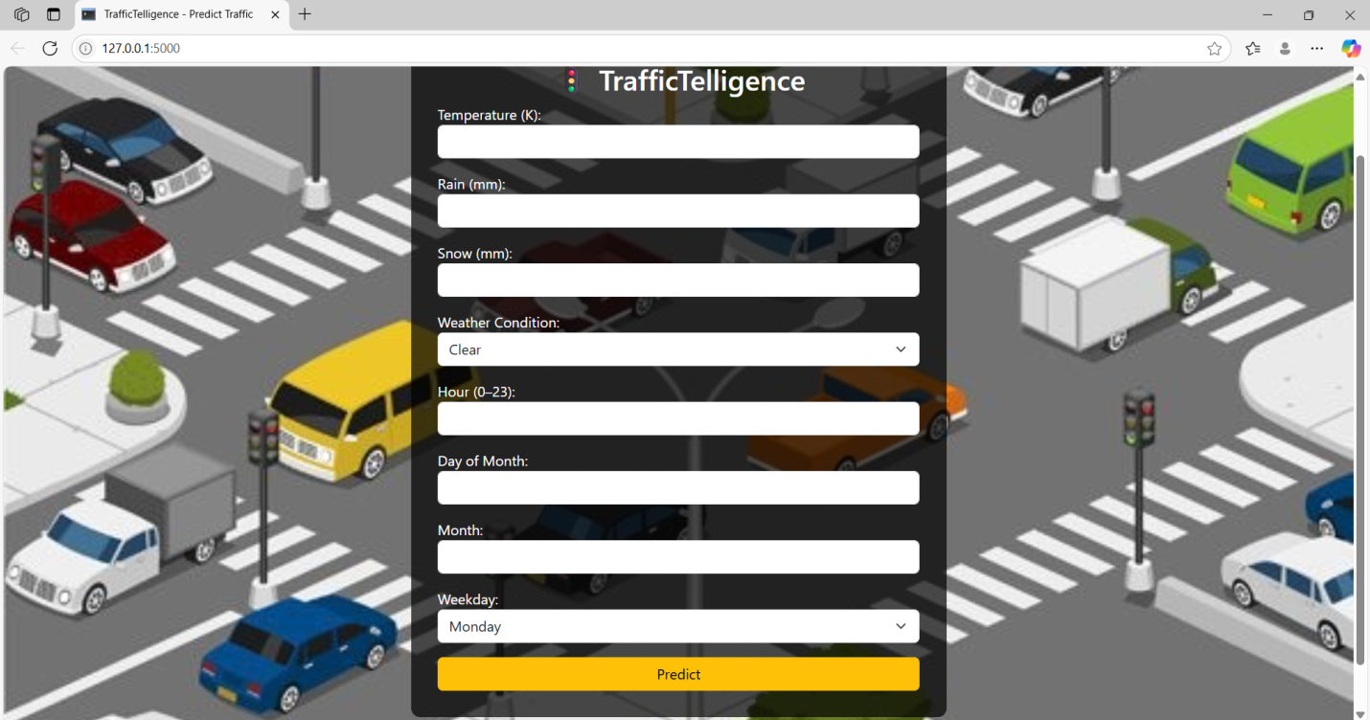

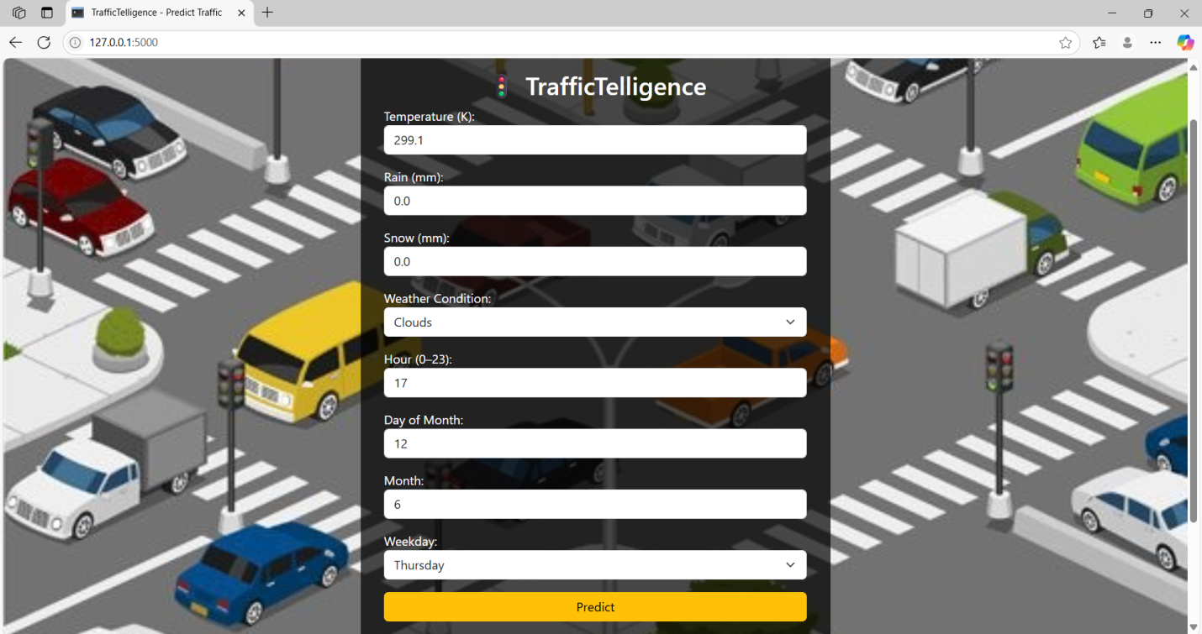

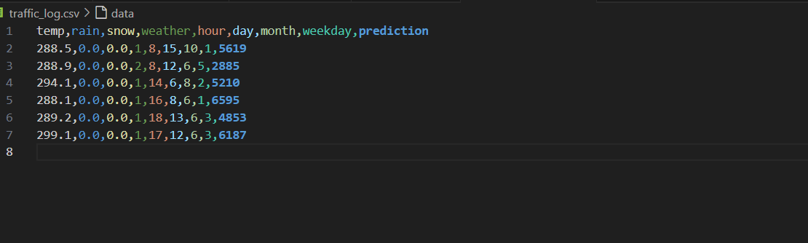

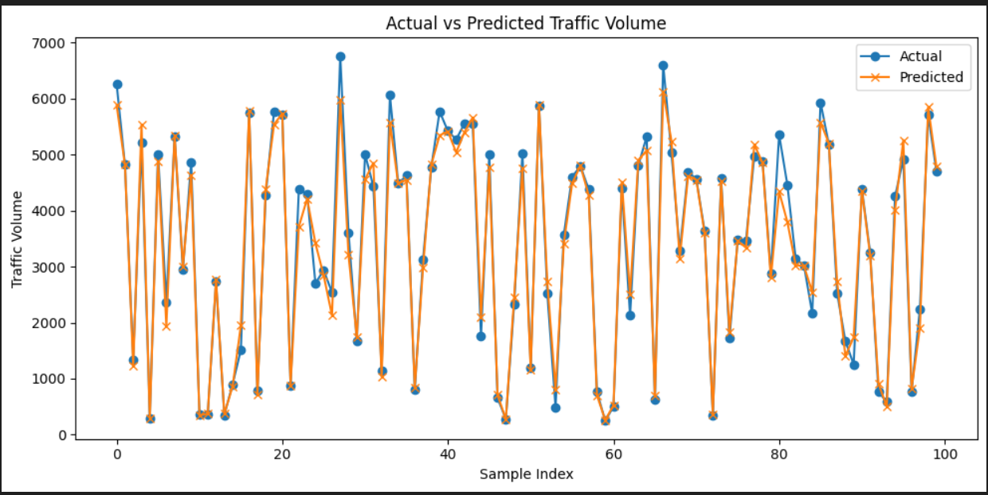

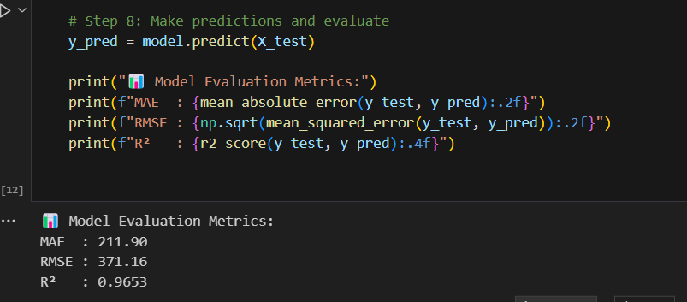

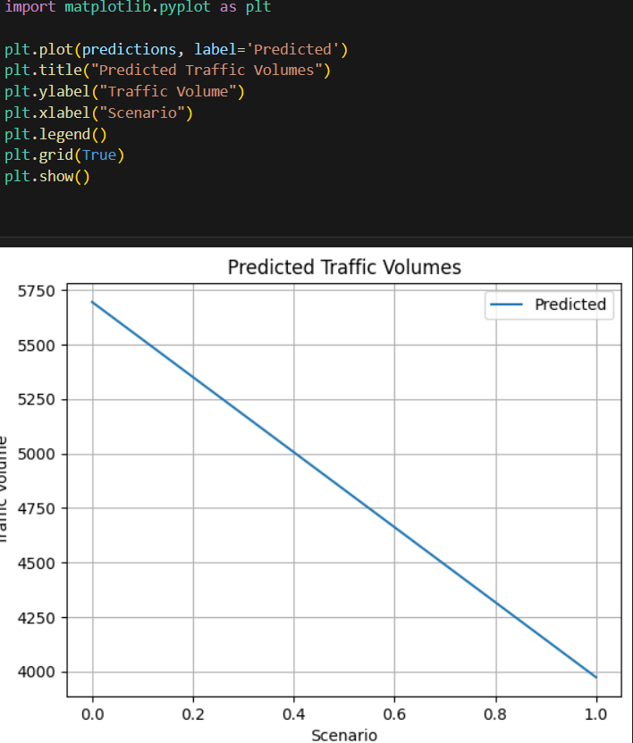

8. ADVANTAGES & DISADVANTAGES
Advantages:
- Real-time traffic estimation
- Easy to use interface
- Lightweight web-based solution
Disadvantages:
- Predictions rely on static data
- Lacks live sensor/GPS inputs

9. CONCLUSION
TrafficTelligence proves that ML can enhance traffic prediction for smart cities. It can reduce congestion and help better decision-making for commuters and administrators.

10. FUTURE SCOPE
- Integrate with real-time traffic APIs
- Add GPS and sensor-based input
- Deploy to mobile app platform

11. APPENDIX
- Source Code: Included in GitHub repo
- Dataset Link: https://drive.google.com/file/d/1iV5PfYAmI6YP0_0S4KYy1ZahHOqMgDbM/view
- GitHub: https://github.com/your-username/traffic-telligence
- Project Demo: https://youtu.be/IuEKecKAwMc

